Design an experiment to observe process state transitions (Ready, Running, Waiting, Terminated) using Linux monitoring tools such as ps, top, and /proc. Document the observations.

Code:
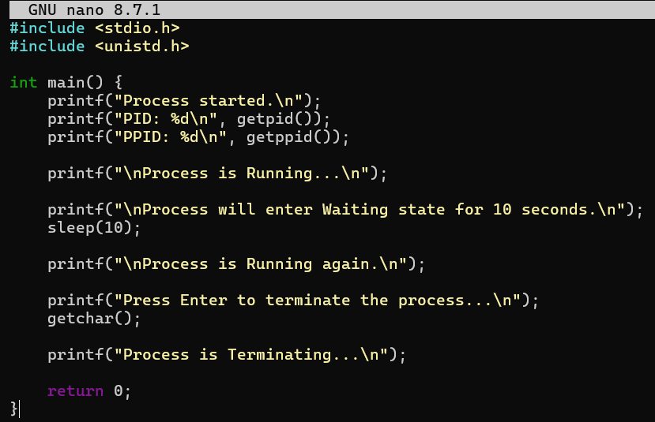

Output:
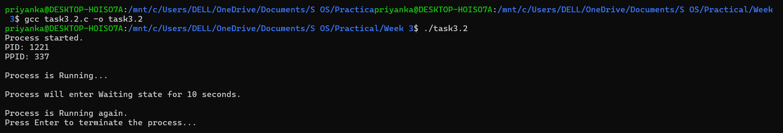
Observation: The top command showed 27 processes: 1 running, 26 sleeping, 0 stopped, and 0 zombie processes. The R state represents a running/runnable process, while S represents a sleeping/waiting process. Most processes were in the sleeping state because they were waiting for events or CPU time. No stopped or zombie processes were observed during the experiment.

